FreelanceFinder: Discovering Opportunities, Unlocking Potential
FreelanceFinder is an intelligent online freelancing platform that leverages modern web technologies to provide structured, secure, and interactive collaboration between clients and freelancers. It integrates full-stack development concepts using the MERN stack to enable project posting, proposal submission, real-time communication
n, secure authentication, project tracking, and admin monitoring. The platform supports multiple user roles such as Admin, Client, and Freelancer, ensuring controlled access and organized workflow management.
Essentially, FreelanceFinder is designed to create an efficient, user-friendly, and scalable freelancing environment that enhances professional collaboration, simplifies project management, and promotes secure remote work opportunities through technology.
IDEATION PHASE
Brainstorm & Idea Prioritization:
Brainstorming was conducted to explore different approaches for building a modern freelancing system. Initially, ideas such as a simple job listing website and a basic bidding platform were considered. However, these ideas lacked secure authentication mechanisms, structured proposal workflows, real-time communication features, and proper admin control.
Through collaborative evaluation and prioritization, the team identified the need for a complete freelancing platform that supports secure JWT authentication, role-based access control, structured project posting, proposal management, real-time chat integration using Socket.io, and transparent project tracking.
Idea prioritization was performed based on feasibility, scalability, technical complexity, security requirements, and real-world relevance. The MERN stack was selected due to its flexibility, performance, scalability, and strong industry demand. The final idea, FreelanceFinder, was chosen because it delivers a complete freelancing lifecycle while demonstrating advanced backend development, authentication, and real-time communication concepts.
REQUIREMENT ANALYSIS
Customer journey map:
Creating a customer journey map for FreelanceFinder involves understanding how Clients, Freelancers, and Administrators interact with the platform at different stages. The journey begins with user registration and secure login, followed by project posting or browsing, proposal submission, freelancer selection, real-time communication, project completion, and feedback exchange. Clients manage project requirements, freelancers handle proposal submission and task execution, while administrators oversee system monitoring and user management.
This structured journey ensures a smooth, secure, and transparent freelancing experience, promoting efficient collaboration and trust among all users

Data Flow Diagram:
FreelanceFinder is a digital freelancing platform designed to help clients, freelancers, and administrators manage project-based collaboration efficiently using modern web technologies. It integrates technologies such as the MERN stack, JWT authentication, Bcrypt encryption, real-time communication with Socket.io, and structured database management to handle project posting, secure login, proposal submission, project tracking, and workflow management.
By combining structured project management with secure authentication and automated collaboration processes, FreelanceFinder ensures a smooth, transparent, and scalable freelancing experience for all users.
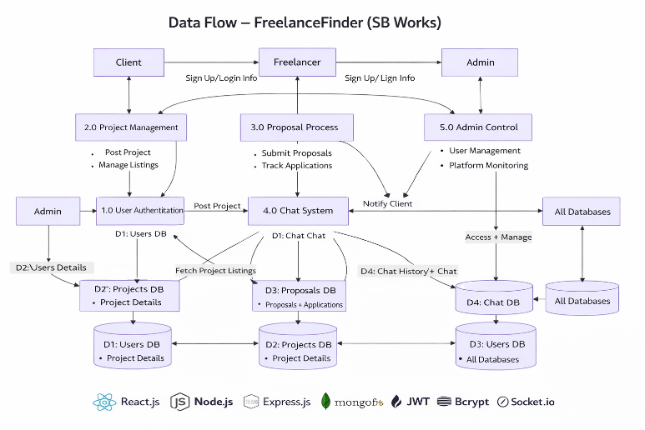
Technology stack:
To build the LearnHub Online Learning Platform, a robust and scalable MERN stack technology stack is used to ensure secure authentication, structured course management, payment verification, and seamless user interaction.
Layer | Technologies / Tools | Purpose
User Interface (UI) | React.js, Bootstrap, CSS | Interactive web interface for Client,User and admin dashboards
Application Layer | Node.js, Express.js | Backend business logic, REST API routing, role-based access control
Authentication & Security | JWT (JSON Web Token), bcrypt | Secure login, password hashing, role-based authorization
Data Layer |  | Structured data storage for users, payments, enrollments
  MongoDB, Mongoose
File Handling Layer | Multer | Video file uploads and storage management
API Communication | RESTful APIs, Axios | Frontend-backend communication
Deployment & Environment | Node runtime, Git, npm | Version control and application environment management

Technical Architecture:
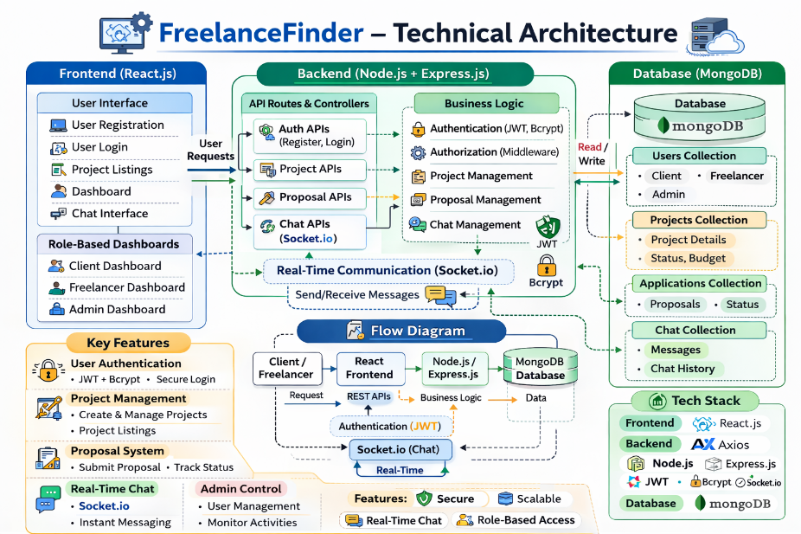

DESIGN PROJECT
Problem–Solution Fit:
• Clients struggle to track project progress and ensure timely delivery
→ FreelanceFinder provides structured project status tracking (Open, In Progress, Completed) and submission management.
• Freelancers face difficulty showcasing skills and managing multiple proposals
→ FreelanceFinder offers a dedicated freelancer dashboard with proposal tracking and profile management features.
• Lack of secure communication can cause misunderstandings
→ FreelanceFinder integrates real-time chat using Socket.io for structured and secure communication.
• Administrators need control over platform users and project activities
→ FreelanceFinder implements role-based access control (Admin, Client, Freelancer) using JWT authentication and middleware protection.
• No centralized system for managing projects, proposals, and collaboration
→ FreelanceFinder integrates project posting, proposal handling, selection workflow, communication, and admin monitoring into a unified system.
• Many freelancing platforms lack secure authentication
→ FreelanceFinder uses JWT and bcrypt to ensure secure login and password protection.

Proposed Solution:
1. Role-Based Freelancing Platform
• Separate dashboards for Admin, Client, and Freelancer.
• Secure authentication and authorization using JWT and bcrypt.
2. Structured Project Management
• Clients can create and manage projects with detailed descriptions, budget, and deadlines.
• Projects organized with clear status tracking.
3. Secure Proposal & Selection System
• Freelancers can submit structured proposals.
• Clients can review and select freelancers securely.
4. Real-Time Communication System
• Chat integration using Socket.io.
• Secure project-based communication channels.
5. Project Tracking & Submission
• Track project status updates.
• Freelancers can submit completed work.
6. Scalable MERN Architecture
• React frontend for interactive UI.
• Node.js & Express backend for API management.
• MongoDB for data storage and scalability.
7. Secure & Structured Workflow
• Role-based middleware protection.
• RESTful API communication between frontend and backend.
• Encrypted passwords and token validation.

Solution Architecture:
• User Interaction Layer
o Interfaces: Web application (React.js)
o Purpose: Allows Clients, Freelancers, and Admins to interact with the platform
• Application & Service Layer
o Technologies: Node.js, Express.js
o Functions: Handles business logic, routing, project workflows, and chat integration
• Authentication & Security Layer
o Technologies: JWT, bcrypt
o Purpose: Secure login, password hashing, and role-based access control
• Data Management Layer
o Database: MongoDB
o Stores: User data, project details, proposals, chat history, status tracking
• Real-Time Communication Layer
o Technology: Socket.io
o Purpose: Enable instant messaging between clients and freelancers
• Integration & API Layer
o Interfaces: RESTful APIs, Axios
o Purpose: Connect frontend and backend securely
• Deployment & Runtime Layer
o Platform: Node.js runtime environment
o Role: Server execution, scalability, and system reliability

FUNCTIONAL AND PERFORMANCE TESTING
Functional Testing
• Verify user registration and login functionality works correctly with secure JWT authentication.
• Test role-based access control to ensure Admin, Client, and Freelancer dashboards are properly restricted.
• Validate project creation and proposal submission functionality.
• Ensure freelancer selection and project status workflows function correctly end-to-end.
• Confirm real-time chat functionality works without message loss.
• Test API endpoints for accurate data retrieval and updates (projects, applications, chats).
• Confirm password encryption using bcrypt and secure token validation.

Performance Testing
• Conduct load testing to simulate multiple users browsing and posting projects simultaneously.
• Perform stress testing to evaluate backend stability under high traffic conditions.
• Measure API response time for project listing, proposal submission, and chat interactions.
• Test real-time chat performance during concurrent messaging.
• Validate database query efficiency for large numbers of users and projects.
• Monitor server resource usage (CPU, memory, storage) during peak operations.
• Evaluate system scalability for increasing users and project volume.
RESULTS

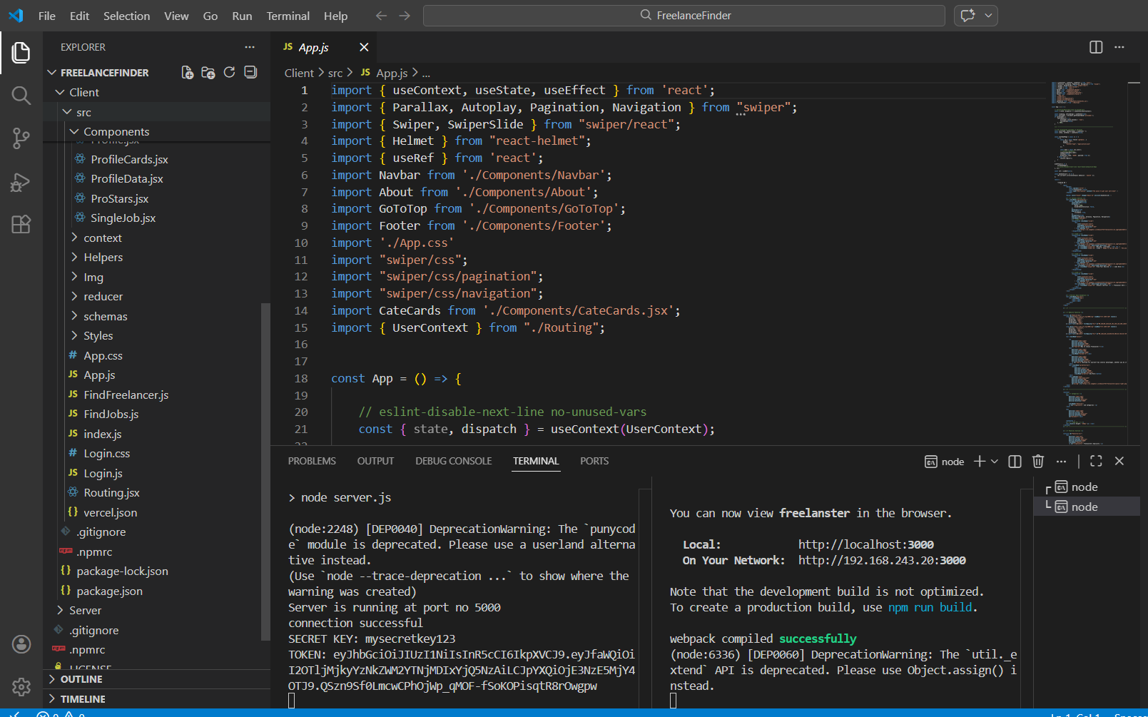

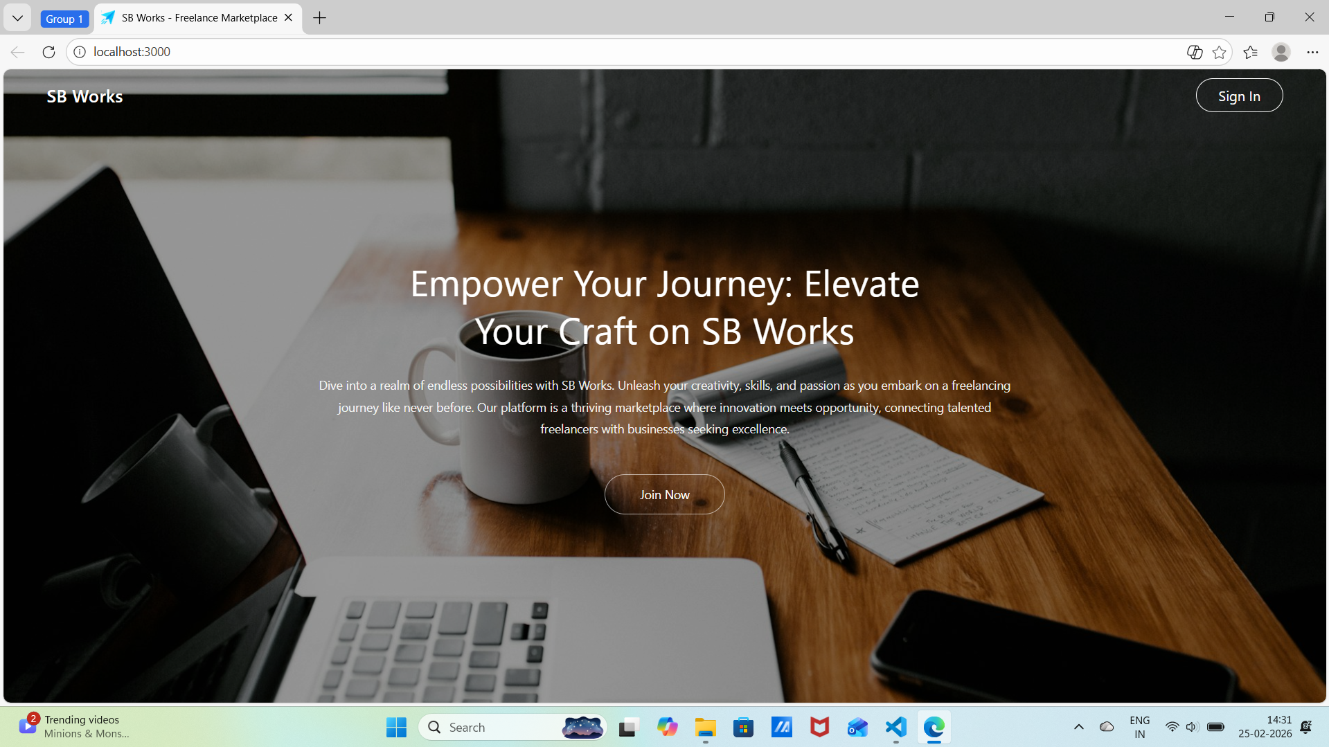
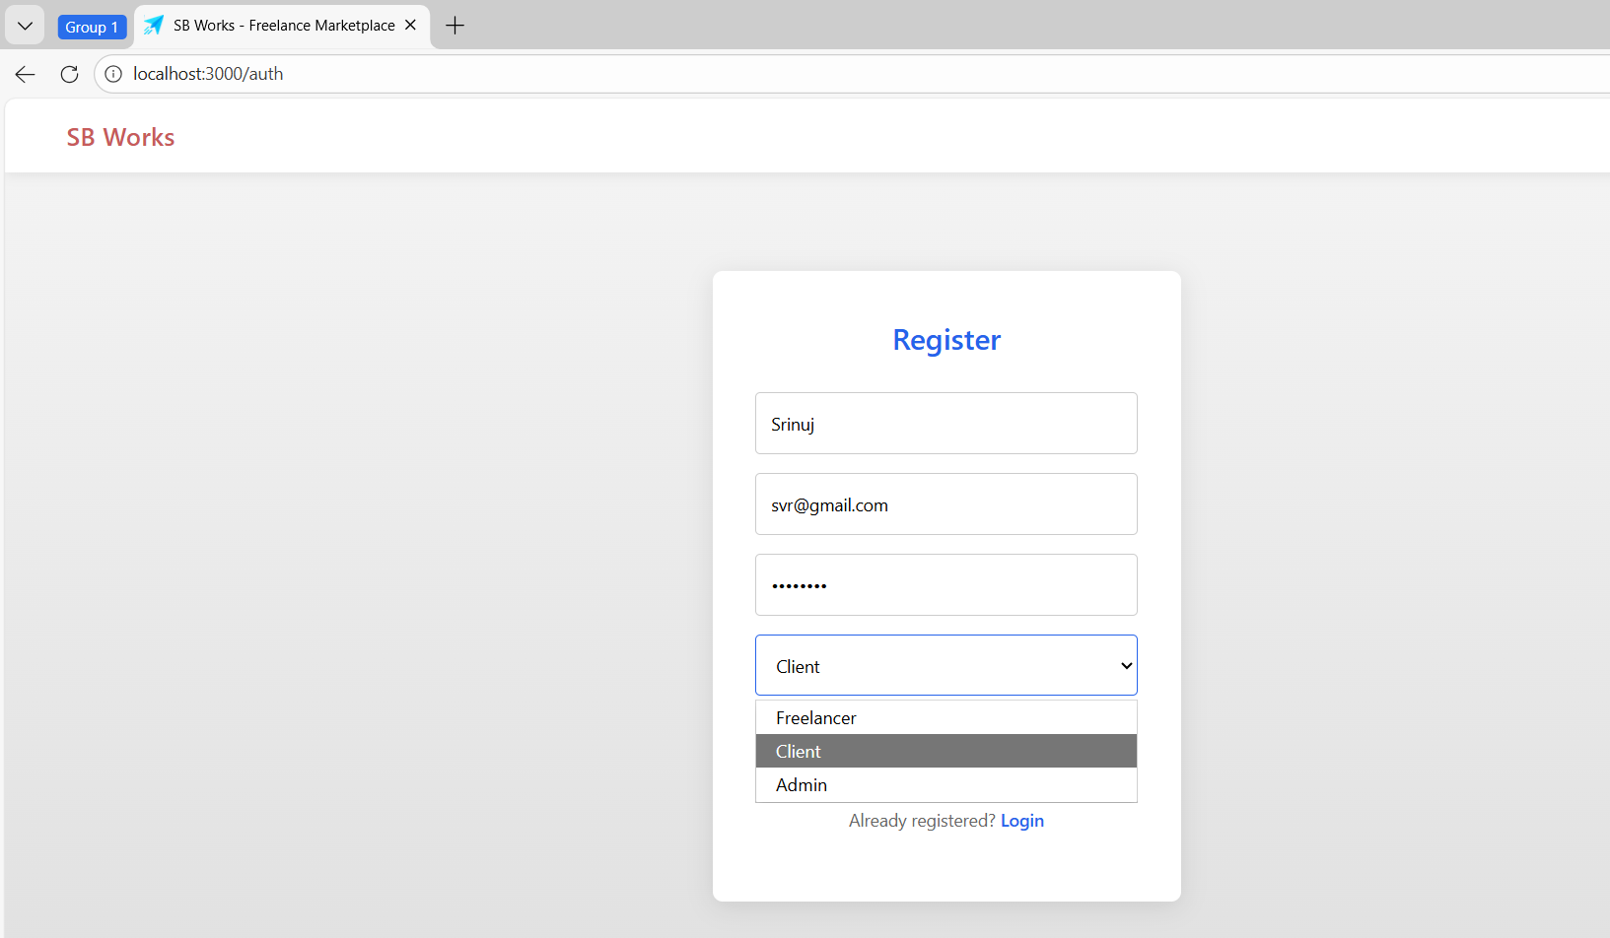
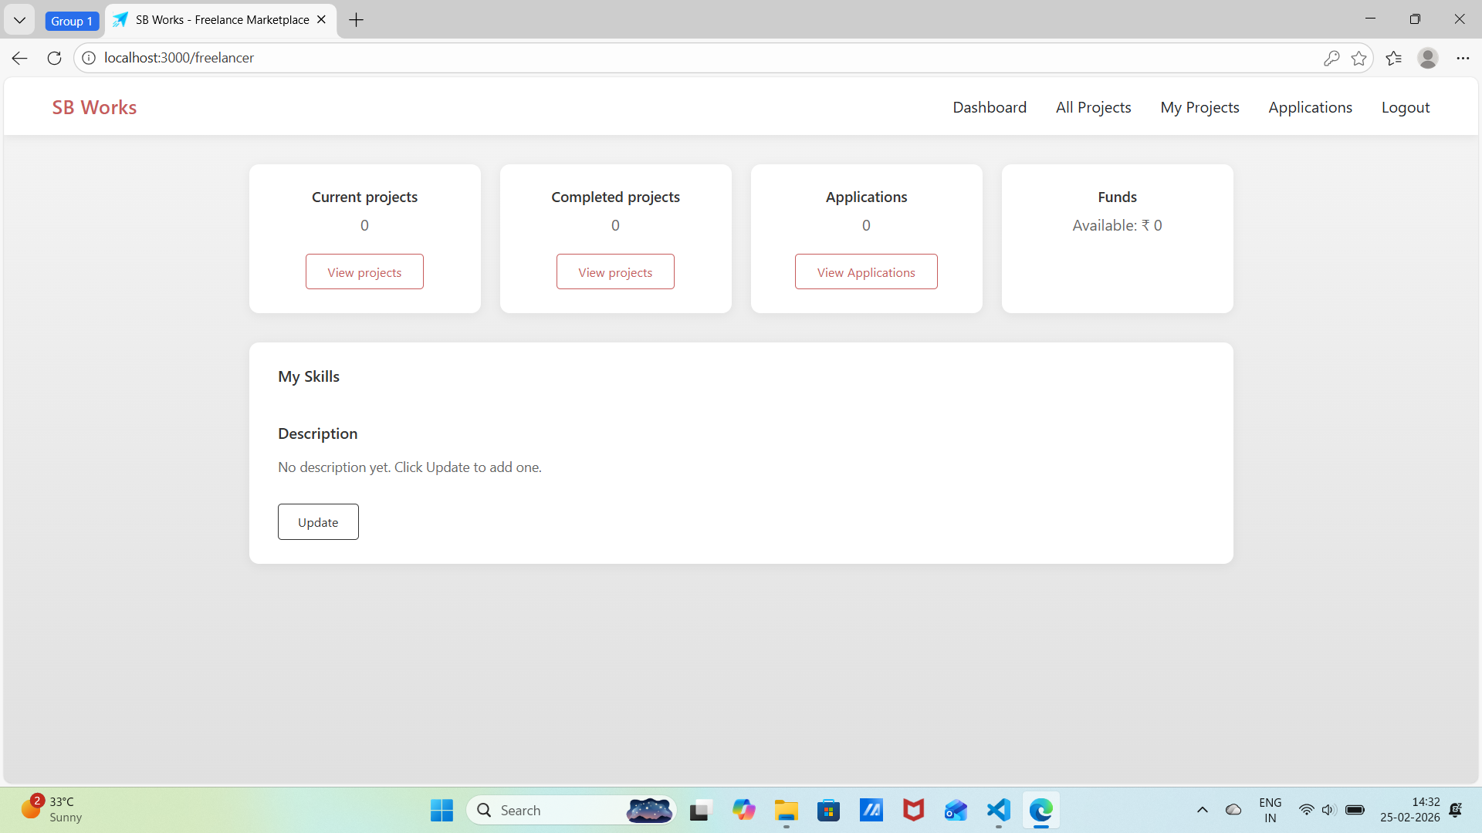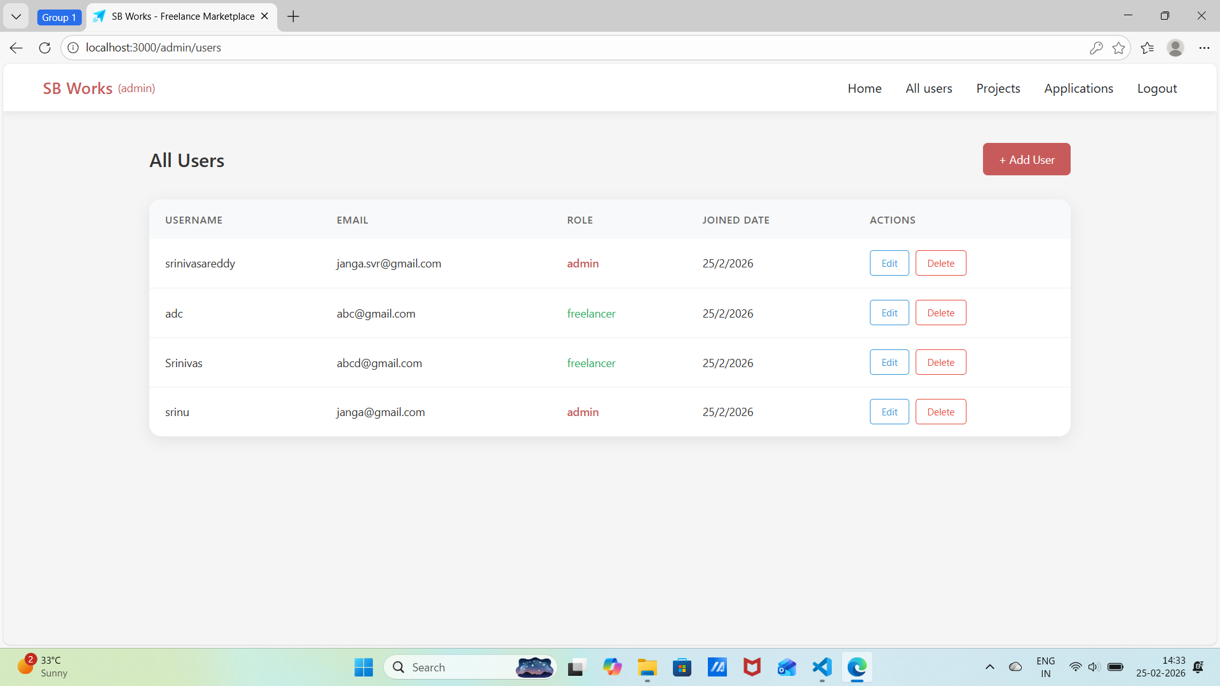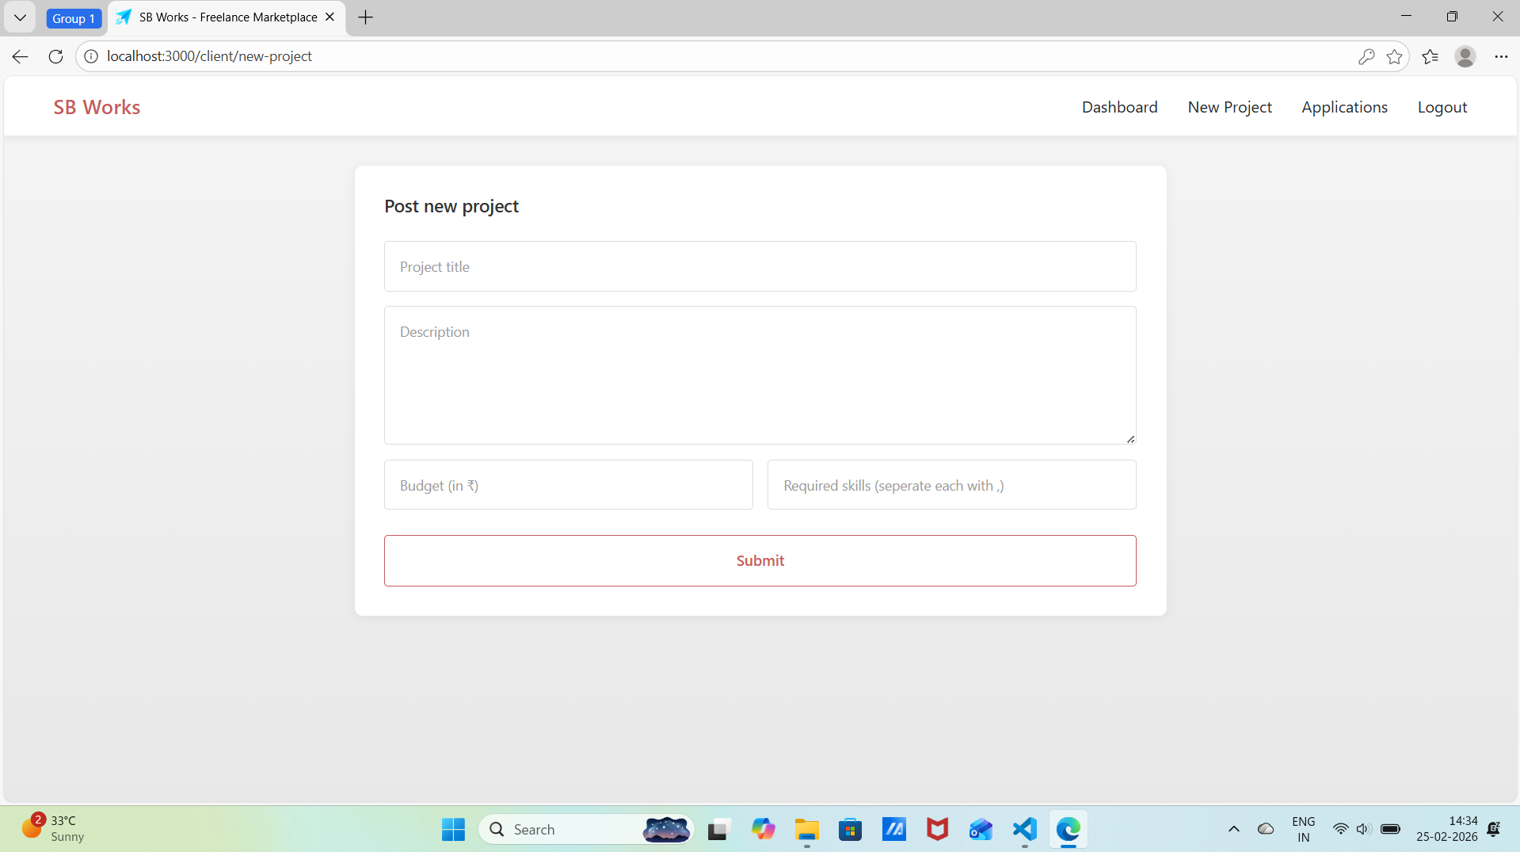
ADVANTAGES & DISADVANTAGES:
Advantages
- Provides secure authentication and role-based access control (Admin, Client, Freelancer).
- Enables structured project posting and proposal management.
- Supports real-time communication using Socket.io.
- Ensures secure password encryption using bcrypt and JWT-based session management.
- Offers separate dashboards for Admin, Client, and Freelancer.
- Allows efficient project tracking and status monitoring.
- Built on a scalable MERN stack architecture.
- Organized management of projects, proposals, and chat history.
- Enhances remote work opportunities and professional collaboration.
- Demonstrates real-world full-stack development with authentication, database integration, and real-time features.

Disadvantages
- No real payment gateway integration (if monetization is added in future).
- Chat and file storage may rely on local hosting (not cloud-based initially).
- Requires continuous server availability for real-time communication.
- Limited advanced features (e.g., AI-based freelancer recommendations).
- Performance depends on hosting infrastructure and server configuration.
- Initial setup and deployment complexity.
- No automated dispute resolution system.
- Limited offline functionality.
- Requires regular maintenance and security updates.
- Scalability depends on database optimization and server resources.

CONCLUSION
The FreelanceFinder platform represents a comprehensive and scalable digital freelancing solution built using the MERN stack. By integrating secure authentication, role-based access control, structured project management, proposal handling, real-time communication, and admin monitoring, the system delivers a complete freelancing workflow experience.
FreelanceFinder bridges the gap between clients seeking reliable talent and freelancers searching for genuine opportunities by providing a secure, transparent, and organized collaboration environment. Its modular architecture, scalable backend design, and real-time communication features demonstrate practical real-world full-stack development capabilities.
However, the platform can be further enhanced by integrating secure payment gateways, cloud-based file storage, AI-driven project recommendations, and advanced analytics features. With continuous improvements and optimized deployment strategies, FreelanceFinder has strong potential to evolve into a fully production-ready freelancing marketplace.

FUTURE SCOPE
• AI-Based Freelancer Recommendation System
Machine learning algorithms can analyze user behavior, skills, and project history to recommend suitable freelancers or projects.
• Real Payment Gateway Integration
Integration with secure payment platforms such as Razorpay or Stripe to enable real-time project payments and commission handling.
• Cloud-Based File Storage
Migrating project submissions and attachments to cloud platforms like AWS S3 or Google Cloud Storage for better scalability and reliability.
• Automated Dispute Resolution System
Implementing structured conflict resolution workflows between clients and freelancers.
• Mobile Application Development
Development of Android and iOS applications to improve accessibility and engagement.
• Analytics & Reporting Dashboard
Advanced analytics for tracking project performance, freelancer ratings, client activity, and revenue insights.
• Multi-Language Support
Enabling multilingual interfaces to support global users.

Submitted by:
Janga Srinivasa
Megha Sindhu Indukuri
Lohitha Sri Vasavi Kanikalla
M S S C Kumar

